PROJECT REPORT OF CO-OP Project at Industry (Module-2)
ON
Traffic Sign Recoginition Using R-CNN and Deep Learning
submitted in partial fulfilment of the requirements for the award of degree of

BACHELOR OF ENGINEERING
In
COMPUTER SCIENCE AND ENGINEERING

Submitted by: Supervised By: Simarjit Kaur
Sanya Bansal-2210992256 Associate Professor
Vishesh-2210992539
Shivanshu Saini-2210992331
Sharad Jindal-2210992286


DEPARTMENT OF COMPUTER SCIENCE AND ENGINEERING

CHITKARA UNIVERSITY INSTITUTE OF ENGINEERING AND TECHNOLOGY
CHITKARA UNIVERSITY, PUNJAB, INDIA

CONTENTS

S.No. | Title | Page No.
 | Acknowledgement | iv
 | List of Figures and Tables | v
 | Abstract
1 | Introduction | 1
2 | Methodology
3 | Tools and Technologies
4 | Implementation
5 | Major Findings/Outcomes/Output/Results
6 | Conclusion and Future Scope
 | References
 | Appendices

DECLARATION

I hereby certify that the work which is being presented in the project report entitled “Traffic Sign Recogination Using R-CNN and Deep Learning” in partial fulfilment of requirement for the award of the degree of Bachelor of Engineering (Computer Science and Engineering) submitted in the department of Computer Science and Engineering at Chitkara University Institute of Engineering and Technology, Chitkara University, Punjab, India, is an authentic record of my own work carried out under the supervision of <Simarjit Kaur>. The matter presented in this project report has not been submitted in any other university/institute for the award of any degree.

Place: Rajpura (Name of the Student)
Date: …………….. (University Roll No………………….)

This is to certify that the above statement made by the candidate is correct to the best of my knowledge and belief.

Simarjit Kaur
Associate Professor
Department of Computer Science and Engineering
Chitkara University Institute of Engineering and Technology,
Chitkara University, Punjab, India

ACKNOWLEDGEMENT

- Introduction ( 16 Times New Roman, Bold)

  - Subheading 1 (14 Times New Roman, Bold)

<Main text> (12 Times New Roman 1.5 line spacing)
I would like to express my sincere gratitude to my faculty mentors and guides for their continuous support, valuable suggestions, and constant encouragement throughout the development of this project. Their expertise, patience, and willingness to guide me at every stage played a crucial role in shaping this research work and enhancing its overall quality. I am also deeply thankful to my teammates for their cooperation, teamwork, and dedication. Working together not only made the process smoother but also enriched the project with diverse ideas and perspectives. Their commitment and collaborative spirit significantly contributed to the successful completion of this work. I would like to extend my appreciation to my institution, Chitkara University, for providing a conducive learning environment, necessary infrastructure, and resources required to carry out this project effectively. The academic support and facilities offered by the university were instrumental in achieving the desired outcomes. Furthermore, I am grateful to all those individuals, including technical staff and peers, who directly or indirectly supported me during the course of this project. Their timely help and suggestions made a meaningful difference. Lastly, I express my heartfelt thanks to my family and friends for their unwavering support, motivation, and belief in me. Their encouragement helped me stay focused and confident, especially during challenging phases of this project.

ABSTRACT

Traffic Sign Recognition (TSR) plays a crucial role in modern intelligent transportation systems and autonomous driving technologies, where accurate and real-time decision-making is essential for ensuring road safety. This project presents a deep learning-based approach for automatic detection and recognition of traffic signs using an improved model called Refined Mask R-CNN (RMR-CNN), which enhances both detection accuracy and segmentation performance. A custom dataset containing 6480 images and 7056 traffic sign instances across multiple categories was developed to train and evaluate the model effectively. The system integrates advanced preprocessing techniques such as shape detection, region of interest (ROI) extraction, and color probability analysis to improve feature representation. Additionally, various data augmentation methods, including rotation, scaling, and brightness adjustments, were applied to increase dataset diversity and reduce overfitting. The proposed model achieved an accuracy of approximately 97%, outperforming traditional models like Fast R-CNN and Mask R-CNN in both precision and reliability. The results highlight the robustness and efficiency of the approach in handling complex traffic scenarios. This work demonstrates the significant potential of deep learning techniques in enabling reliable, scalable, and real-time traffic sign recognition systems for next-generation autonomous vehicles and smart city applications.

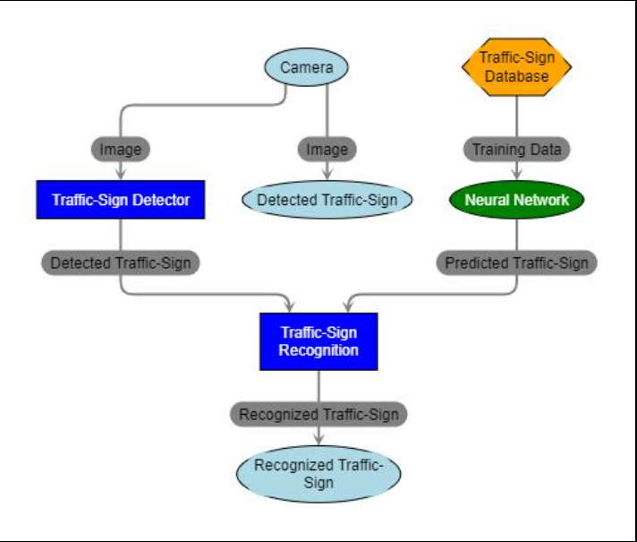

Figure 1: Architecture of Traffic Sign Detection and Recognition System using Deep Learning

- Introduction
Traffic sign recognition is an essential component of Advanced Driver Assistance Systems (ADAS) and autonomous vehicles, playing a vital role in enhancing road safety and driving efficiency. By automatically detecting and interpreting traffic signs, such systems assist drivers in making timely and accurate decisions, thereby reducing the chances of accidents caused by human error or missed visual cues.
In real-world driving conditions, traffic signs can vary significantly in size, color, shape, and orientation. Factors such as poor lighting, weather conditions, motion blur, and occlusion further increase the complexity of accurate detection and recognition. Therefore, building a robust and reliable system capable of performing well under diverse conditions is a challenging yet critical task.
Traditional traffic sign recognition methods relied heavily on manual feature extraction techniques, such as edge detection, color segmentation, and shape analysis. While these approaches provided a foundation, they were often limited in accuracy, scalability, and adaptability to complex environments. The emergence of deep learning, particularly Convolutional Neural Networks (CNNs), has significantly transformed the field of computer vision by enabling automated feature extraction and improving recognition performance.
This project focuses on developing an advanced deep learning-based system for traffic sign recognition that aims to address the limitations of traditional methods. The key objectives of this work include detecting traffic signs in real-time using efficient object detection techniques, accurately classifying them into predefined categories, and enhancing overall system performance through refined deep learning models. The proposed approach leverages improved architectures, optimized preprocessing techniques, and data augmentation strategies to achieve higher accuracy and robustness.
By integrating modern deep learning methodologies, this project contributes to the development of intelligent transportation systems and supports the advancement of autonomous driving technologies, ultimately promoting safer and smarter road environments.
Furthermore, the system is designed to be scalable and adaptable for integration into real-world applications, including smart vehicles and traffic monitoring systems. Future enhancements may include real-time deployment on embedded systems, improved model optimization, and expansion of the dataset to cover a wider variety of traffic scenarios.

- Methdology

The methodology of this project is structured into multiple stages to ensure accurate detection and classification of traffic signs using deep learning techniques. Each stage is carefully designed to handle different aspects of the system, from data preparation to final model evaluation.

2.1 Data Collection :
A custom dataset was created consisting of 6480 images, containing a total of 7056 traffic sign instances. The dataset includes more than 87 traffic sign categories, covering a wide variety of regulatory, warning, and informational signs. Images were collected from real-world road environments to ensure diversity and realism in the dataset. Various sources such as roadside captures, open datasets, and simulated environments were utilized to gather comprehensive data. The dataset includes variations in lighting conditions, weather scenarios, and camera angles to make the model robust against real-world challenges.

Before feeding the data into the model, preprocessing techniques were applied to improve data quality and consistency. This includes resizing images to a uniform dimension, normalization of pixel values, and noise reduction. Region of Interest (ROI) extraction was used to focus on relevant portions of images, reducing unnecessary background information. Additionally, color-based filtering and shape detection methods were used to enhance feature extraction.
To increase dataset diversity and prevent overfitting, various data augmentation techniques were applied. These include image rotation, flipping, scaling, translation, and brightness adjustments. Augmentation helps the model generalize better and perform well on unseen data by simulating different real-world conditions.
The core of the system is based on a refined deep learning model, RMR-CNN (Refined Mask R-CNN). This model improves upon traditional Mask R-CNN by enhancing feature extraction and segmentation capabilities. It is designed to detect traffic signs efficiently while maintaining high accuracy in classification.

The model was trained using the prepared dataset with appropriate hyperparameter tuning. Techniques such as learning rate adjustment, batch normalization, and dropout were implemented to optimize performance and prevent overfitting. The training process was monitored using validation datasets to ensure stability and convergence.
Finally, the model was evaluated using standard performance metrics such as accuracy, precision, recall, and F1-score. The system achieved high accuracy and demonstrated strong performance in detecting and classifying traffic signs under various conditions. This structured methodology ensures the development of a reliable, efficient, and scalable traffic sign recognition system suitable for real-world applications.

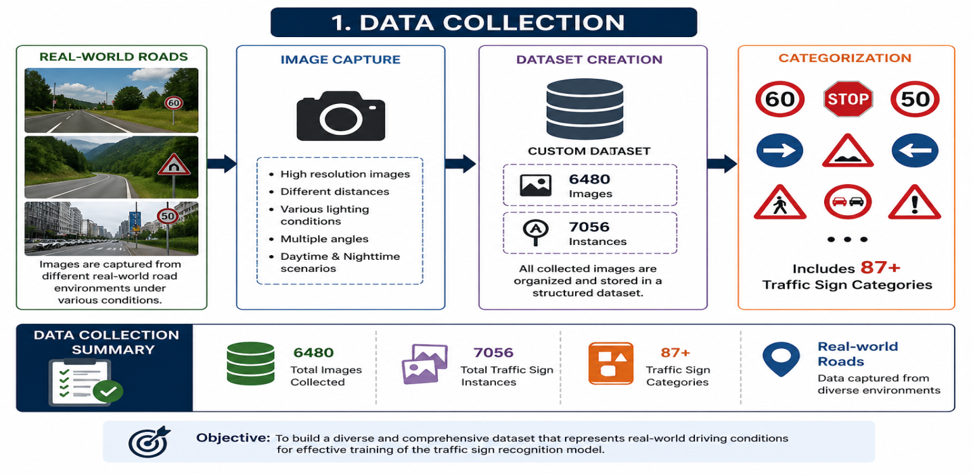
Figure 2: Data Collection Process for Traffic Sign Recognition System

2.2. Preprocessing:
Preprocessing is a critical stage in the traffic sign recognition pipeline, as it directly impacts the accuracy and efficiency of the model. Raw images collected from real-world environments often contain noise, irrelevant background information, lighting variations, and distortions that can negatively affect model performance. Therefore, a series of preprocessing techniques are applied to enhance image quality, highlight important features, and prepare the data for effective learning.
One of the primary techniques used in this stage is shape detection, which helps in identifying the geometric structure of traffic signs. Most traffic signs follow standard shapes such as circles, triangles, and rectangles. By detecting these shapes, the system can quickly narrow down potential regions where traffic signs are likely to be present. Techniques such as edge detection, contour extraction, and Hough Transform are used to identify and classify these shapes accurately. This step significantly reduces the search space and improves detection speed.
Another important step is Region of Interest (ROI) extraction. Instead of processing the entire image, ROI focuses only on the relevant portions where traffic signs are located. This is achieved by filtering out unnecessary background areas and isolating candidate regions based on shape and color features. ROI extraction not only reduces computational complexity but also increases the precision of the model by eliminating noise and irrelevant details.
In addition to shape and spatial filtering, color probability calculation plays a crucial role in preprocessing. Traffic signs are designed with distinctive colors such as red, blue, yellow, and white, which help in their easy identification. RGB analysis is used to calculate the probability distribution of colors within an image. By analyzing the intensity and combination of red, green, and blue channels, the system can detect color-specific patterns associated with different types of traffic signs. Thresholding techniques are applied to highlight dominant colors and suppress less relevant ones.
Furthermore, normalization and resizing of images are performed to ensure uniformity across the dataset. This helps the model process all images consistently, regardless of their original size or resolution. Noise reduction techniques such as Gaussian blur may also be applied to smooth the images and reduce unwanted variations.
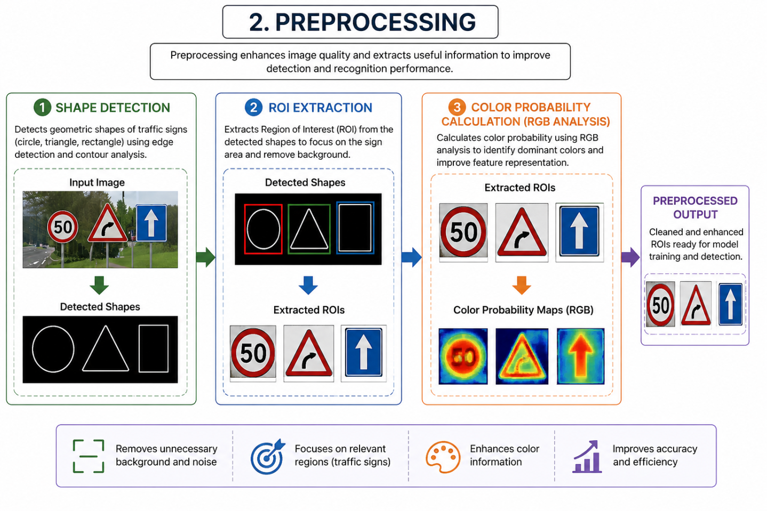
Figure 3: Image Preprocessing Pipeline for Traffic Sign Recognition System.

2.3. Model Selection:
Model selection is a crucial stage in the development of an efficient traffic sign recognition system, as the choice of model directly influences detection accuracy, speed, and overall system performance. In this project, multiple deep learning-based object detection models were studied and compared to identify the most suitable approach for real-time traffic sign detection and classification. The primary models considered include Fast R-CNN, Mask R-CNN, and the proposed refined model, RMR-CNN (Refined Mask R-CNN).
Fast R-CNN is an improved version of the traditional R-CNN model that enhances detection speed and accuracy by processing the entire image through a convolutional neural network only once. It uses a Region of Interest (ROI) pooling layer to extract fixed-size feature maps from proposed regions, which are then classified into different object categories. Fast R-CNN significantly reduces computational time compared to earlier approaches and provides better performance in object detection tasks. However, it is limited in its ability to precisely localize object boundaries, as it mainly focuses on bounding box detection rather than pixel-level segmentation.
To overcome these limitations, Mask R-CNN was introduced as an extension of Fast R-CNN. In addition to detecting objects and generating bounding boxes, Mask R-CNN performs instance segmentation by creating pixel-wise masks for each detected object. This allows for more accurate localization and better understanding of object shapes, which is particularly useful for traffic sign recognition where precise boundaries are important. Mask R-CNN incorporates a parallel branch for mask prediction and improves ROI alignment using ROI Align instead of ROI Pooling, resulting in enhanced performance.
Building upon the strengths of Mask R-CNN, this project proposes an improved model called RMR-CNN (Refined Mask R-CNN). The proposed model introduces refinements in feature extraction, region proposal mechanisms, and classification layers to achieve higher accuracy and robustness. Additional preprocessing integration, optimized hyperparameters, and enhanced training strategies contribute to improved detection performance, especially under challenging conditions such as low lighting, occlusion, and varying sign orientations.
The RMR-CNN model is designed to balance accuracy and efficiency, making it suitable for real-time applications in intelligent transportation systems. Experimental results demonstrate that the proposed model outperforms both Fast R-CNN and Mask R-CNN in terms of accuracy and reliability.
2.4. Data Augmentation
Data augmentation is a vital step in the development of a robust and generalizable traffic sign recognition system. In real-world scenarios, traffic signs appear under varying conditions such as different angles, lighting environments, distances, and camera perspectives. Training a model on limited or uniform data can lead to overfitting, where the model performs well on training data but fails to generalize to unseen images. To address this issue, data augmentation techniques are applied to artificially expand the dataset and introduce variability without the need for additional data collection.
One of the primary augmentation techniques used in this project is rotation. Traffic signs can appear at different orientations due to camera angles or road conditions. By rotating images at various degrees, such as ±15°, ±30°, or even random angles, the model learns to recognize signs regardless of their orientation. This significantly improves the robustness of the model in real-world applications.Another commonly used technique is flipping, which involves horizontally or vertically flipping the images. Horizontal flipping is particularly useful for certain types of traffic signs that may appear mirrored due to camera positioning. This helps the model learn symmetrical patterns and enhances its ability to detect signs from different viewpoints.Brightness adjustment is also an important augmentation method, as lighting conditions can vary greatly depending on the time of day, weather, or environment. By increasing or decreasing the brightness levels of images, the model becomes more adaptable to scenarios such as low-light conditions, shadows, or overexposed environments. This ensures consistent performance across diverse lighting situations.
Zooming is another effective technique used to simulate variations in distance between the camera and the traffic sign. By zooming in and out of images, the model learns to recognize both close-up and distant signs. This is particularly useful in real-world driving scenarios where traffic signs may appear at different scales.In addition to zooming, shifting (translation) is applied to move images horizontally or vertically within the frame. This helps the model understand that the position of the traffic sign within the image can vary and should not affect its classification. Shifting ensures that the model does not become biased toward centrally located objects.Furthermore, combining multiple augmentation techniques creates a more diverse dataset, allowing the model to learn a wide range of variations. This leads to improved generalization, reduced overfitting, and enhanced overall performance.In conclusion, data augmentation plays a crucial role in strengthening the model by exposing it to diverse and realistic scenarios. The use of techniques such as rotation, flipping, brightness adjustment, zooming, and shifting ensures that the traffic sign recognition system is accurate, reliable, and capable of performing effectively in real-world environments.
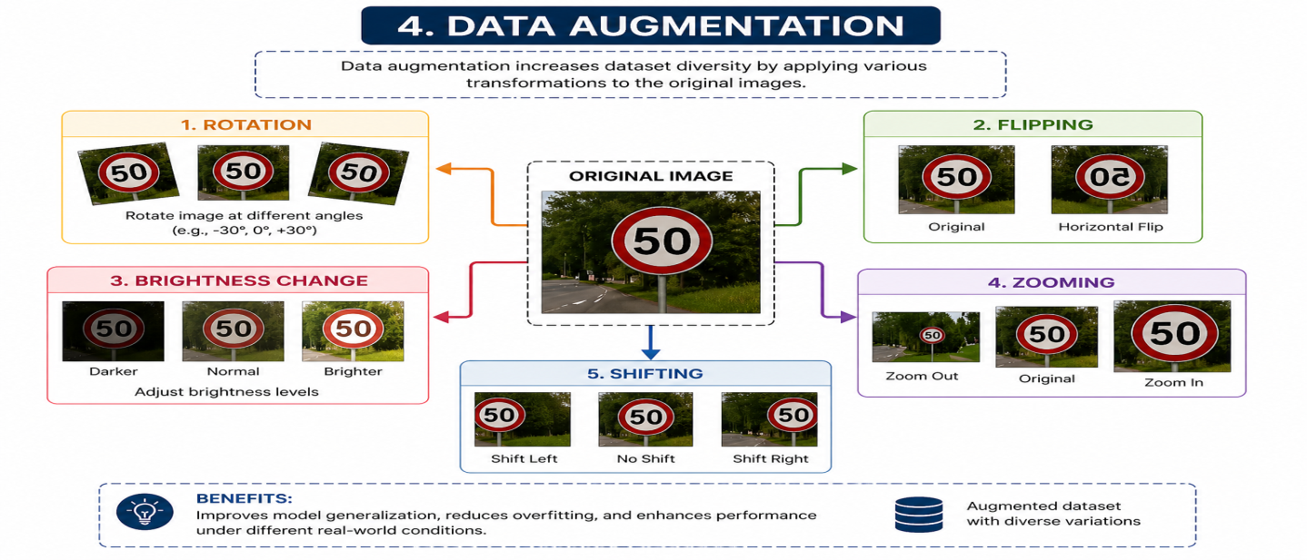
Figure 4: Data Augmentation Techniques Applied for Traffic Sign Recognition

2.5. Training & Testing
The training and testing phase is a crucial component of the traffic sign recognition system, as it determines how effectively the model learns from the dataset and performs on unseen data. In this project, the dataset was divided into two subsets using a standard train-test split ratio of 80:20, ensuring a balanced approach between learning and evaluation. Out of the total dataset, 5664 images were used for training, while 1412 images were reserved for testing the model’s performance.
The training phase involves feeding the preprocessed and augmented images into the deep learning model to enable it to learn distinguishing features of various traffic sign categories. During this process, the model adjusts its internal parameters, such as weights and biases, through backpropagation and optimization techniques like gradient descent. The objective is to minimize the loss function and improve prediction accuracy over multiple iterations, known as epochs. The use of a large and diverse training dataset ensures that the model captures a wide range of patterns, including variations in shape, color, and orientation of traffic signs.To enhance training efficiency and stability, several optimization strategies were employed. These include selecting an appropriate learning rate, using batch processing to handle large datasets, and applying regularization techniques such as dropout to prevent overfitting. Additionally, validation data may be used during training to monitor performance and avoid excessive learning on training data alone. This helps in achieving a well-generalized model.
The testing phase is equally important, as it evaluates how well the trained model performs on unseen data. The testing dataset, consisting of 1412 images, is not used during training, ensuring an unbiased assessment of the model’s performance. Various evaluation metrics such as accuracy, precision, recall, and F1-score are used to measure the effectiveness of the model in correctly detecting and classifying traffic signs.Furthermore, confusion matrices and performance graphs can be analyzed to identify areas where the model may struggle, such as misclassification between similar-looking signs. This insight helps in further refining the model and improving its accuracy.
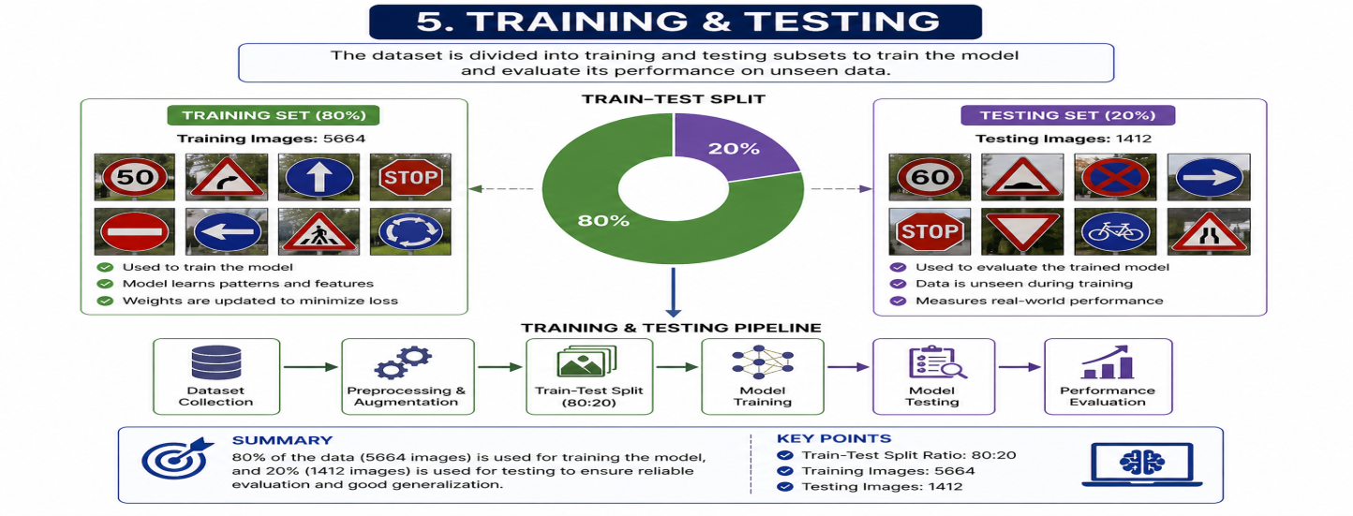
Figure 5: Training and Testing Process with 80:20 Train-Test Split.
3. Tools and Technologies:
The development of the traffic sign recognition system involves a combination of programming languages, libraries, frameworks, deep learning models, and hardware resources. These tools collectively contribute to building an efficient, scalable, and high-performance system capable of handling real-world challenges in image detection and classification.
3.1ProgrammingLanguages
The primary programming language used in this project is Python. Python is widely preferred in the field of artificial intelligence and machine learning due to its simplicity, readability, and extensive support for scientific computing. It provides a rich ecosystem of libraries and frameworks that simplify complex tasks such as data processing, model training, and visualization. Its flexibility allows seamless integration of various components required for building deep learning applications.
3.2LibrariesandFrameworks
Several powerful libraries and frameworks were utilized to implement different stages of the system. TensorFlow and PyTorch are the core deep learning frameworks used for designing, training, and evaluating neural network models. These frameworks offer advanced functionalities such as automatic differentiation, GPU acceleration, and pre-built model architectures, making them ideal for complex tasks like object detection and segmentation.
OpenCV (Open Source Computer Vision Library) plays a crucial role in image processing and computer vision tasks. It is used for operations such as image resizing, filtering, edge detection, and feature extraction. OpenCV helps in implementing preprocessing techniques like shape detection and ROI extraction efficiently.
NumPy is another essential library used for numerical computations. It provides support for large, multi-dimensional arrays and matrices, enabling fast mathematical operations required during data preprocessing and model training. It acts as the backbone for handling image data in array format.
Matplotlib is used for data visualization and graphical representation. It helps in plotting graphs such as accuracy curves, loss functions, and performance metrics, which are essential for analyzing model behavior and training progress.
3.3ModelsUsed:
The project utilizes several deep learning models for traffic sign detection and recognition. Convolutional Neural Networks (CNNs) form the foundation of the system, as they are highly effective in extracting spatial features from images. CNNs automatically learn patterns such as edges, textures, and shapes, making them suitable for image classification tasks.
Fast R-CNN is used for efficient object detection by generating region proposals and classifying them. It improves speed compared to traditional methods but has limitations in precise localization.
Mask R-CNN extends Fast R-CNN by adding a segmentation branch, allowing pixel-level detection of objects. This improves accuracy and helps in better identifying traffic sign boundaries.
The proposed Refined Mask R-CNN (RMR-CNN) further enhances performance by incorporating optimized feature extraction, improved region proposals, and refined classification layers. This model achieves higher accuracy and robustness compared to standard approaches.
3.4Hardware
To handle the computational demands of deep learning, a GPU-enabled system was used for training the models. GPUs significantly accelerate the training process by performing parallel computations, reducing training time and improving efficiency. This is especially important when working with large datasets and complex neural network architectures.
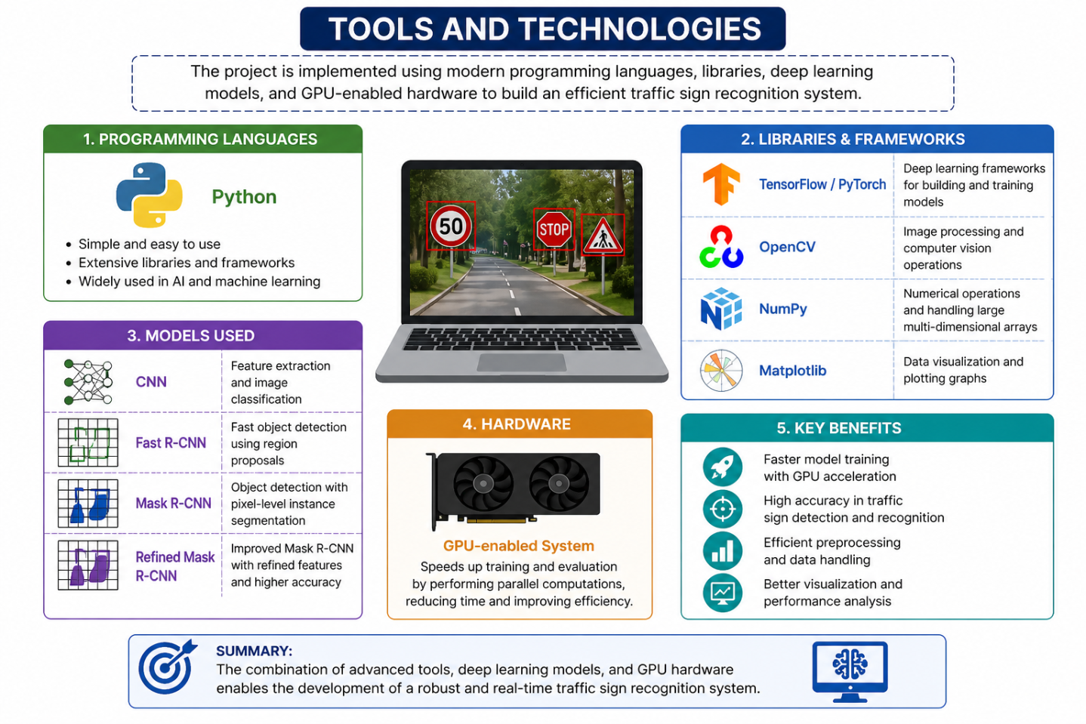
Figure 4: Tools and Technologies Used for Traffic Sign Recognition System
4. Implementation
4.1 Image Input:
The first step in the implementation of the traffic sign recognition system is acquiring input images. These images serve as the foundation for the entire pipeline, as the quality and diversity of input data directly influence the system’s performance and accuracy. In this project, images are captured from real-time environments as well as collected from a pre-built dataset to ensure a comprehensive and diverse input source.
Real-time image capture is typically performed using cameras mounted on vehicles, mobile devices, or surveillance systems. These cameras continuously capture frames from road environments, allowing the system to process live data. Real-world image acquisition introduces various challenges such as motion blur, varying lighting conditions, weather effects, and occlusions. However, including such real-time inputs is essential for building a robust and practical system that can operate effectively in real-world scenarios.
In addition to real-time capture, a structured dataset is used to supplement the training and testing process. The dataset contains images collected from different road conditions, geographic locations, and environmental settings. This ensures that the model is exposed to a wide variety of traffic signs, backgrounds, and perspectives. The inclusion of both real-time and dataset images helps in improving the generalization capability of the model.
Before passing the images to the next stages, basic input handling techniques are applied. These include verifying image formats, resizing images to a consistent resolution, and converting them into a suitable format for processing, such as arrays or tensors. This step ensures uniformity across all inputs and prepares them for preprocessing and feature extraction.
Another important aspect of this step is handling different input sources. The system is designed to accept images from multiple formats such as JPEG, PNG, or video frames. In the case of video input, frames are extracted at regular intervals and processed individually. This enables the system to function in both static and dynamic environments.
Furthermore, proper labeling and annotation of dataset images are maintained to ensure accurate training. Each image is associated with corresponding traffic sign labels and bounding box information, which are essential for supervised learning.
Overall, the image input stage plays a critical role in setting up the entire pipeline. By combining real-time image acquisition with a well-structured dataset, the system ensures high-quality input that contributes to improved detection accuracy and reliable performance in traffic sign recognition tasks.

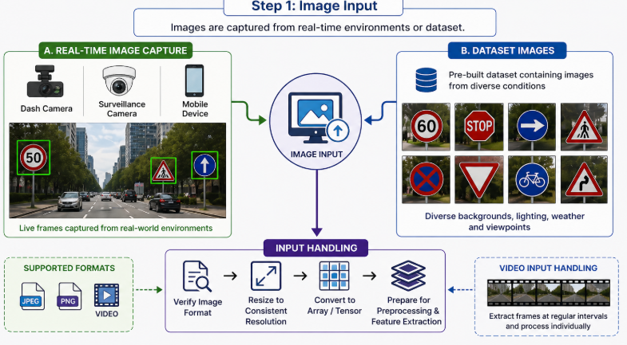
4.2: Pre-processing
Pre-processing is a vital stage in the implementation of the traffic sign recognition system, as it prepares raw input images for efficient analysis and improves the overall performance of the model. The images obtained from real-world environments or datasets often contain noise, varying lighting conditions, and unnecessary background elements. Therefore, preprocessing techniques are applied to enhance image quality, reduce complexity, and highlight important features.
The first step in preprocessing is converting the image to grayscale. In this process, colored images are transformed into a single-channel grayscale format by reducing RGB values into intensity levels. This simplifies the data and reduces computational load, as the model no longer needs to process three color channels. Grayscale conversion is particularly useful for shape-based detection, where color information is less critical than structural features.
Next, shape detection using OpenCV is performed. OpenCV provides powerful tools for identifying geometric structures such as circles, triangles, and rectangles, which are commonly found in traffic signs. Techniques like edge detection (Canny edge detector) and contour analysis are used to locate boundaries and identify shapes within the image. Detecting these standard shapes helps in narrowing down potential regions where traffic signs are present, thereby improving detection efficiency.
Following shape detection, the system performs Region of Interest (ROI) extraction. ROI extraction focuses only on relevant portions of the image that are likely to contain traffic signs, while removing unnecessary background areas. By isolating these regions, the system reduces noise and computational overhead, allowing the model to concentrate on meaningful features. ROI extraction plays a crucial role in improving both speed and accuracy.
Additionally, preprocessing may include resizing images to a consistent resolution, normalizing pixel values, and applying noise reduction techniques such as Gaussian blur. These steps ensure uniformity across the dataset and enhance the clarity of important features.
4.3: Feature Extraction
Feature extraction is a critical step in the traffic sign recognition pipeline, as it involves identifying and extracting meaningful patterns from preprocessed images. These features serve as the foundation for classification, enabling the model to distinguish between different types of traffic signs accurately.
One of the primary techniques used in this stage is RGB color analysis. Traffic signs are designed with distinct and standardized colors such as red, blue, yellow, and white, which play a significant role in their identification. By analyzing the Red, Green, and Blue channels of an image, the system can detect dominant color patterns associated with specific categories of traffic signs. For example, red is often associated with warning or prohibition signs, while blue indicates informational signs. RGB analysis helps in enhancing these color-based features, making it easier for the model to classify signs correctly.
Another important technique is pixel intensity mapping. This process involves analyzing the brightness values of pixels across the image to identify patterns, edges, and textures. Pixel intensity mapping helps in capturing fine details such as symbol shapes, text, and boundaries within traffic signs. These details are crucial for differentiating between visually similar signs.
In addition to these methods, feature extraction may also involve detecting edges, gradients, and textures using advanced techniques. These extracted features are then converted into numerical representations that can be processed by machine learning models. The quality of feature extraction directly impacts the accuracy and efficiency of the classification process.
Furthermore, combining both color-based and intensity-based features provides a more comprehensive understanding of the image. This hybrid approach improves the model’s ability to handle variations in lighting, orientation, and environmental conditions.
In conclusion, the feature extraction stage plays a key role in transforming visual information into meaningful data that the model can interpret. By leveraging RGB color analysis and pixel intensity mapping, the system ensures accurate recognition and classification of traffic signs in real-world scenarios.

4.4: Model Training
Model training is one of the most crucial stages in the implementation of the traffic sign recognition system, as it enables the model to learn patterns and features from the dataset. In this step, Convolutional Neural Network (CNN)-based models are trained using the preprocessed and augmented dataset. CNNs are highly effective in image-based tasks because they automatically learn spatial hierarchies such as edges, textures, and shapes from input images.The training process begins by feeding labeled images into the model. Each image is associated with a corresponding class label, which helps the model understand the relationship between input features and output categories. During training, the model processes images through multiple convolutional layers, pooling layers, and fully connected layers to extract features and make predictions. The difference between predicted outputs and actual labels is calculated using a loss function, and the model parameters are updated through backpropagation.
To improve the robustness and generalization capability of the model, data augmentation techniques are applied during training. Augmentation methods such as rotation, flipping, scaling, and brightness variation introduce diversity into the dataset, allowing the model to learn from different perspectives and conditions. This helps in reducing overfitting and ensures that the model performs well on unseen data.Hyperparameter tuning is also an important aspect of this stage. Parameters such as learning rate, batch size, number of epochs, and optimizer selection (e.g., Adam or SGD) are carefully chosen to achieve optimal performance. Regularization techniques like dropout and batch normalization are used to stabilize training and prevent overfitting.
Additionally, the training process is monitored using validation datasets and performance metrics such as accuracy and loss curves. These metrics help in understanding whether the model is learning effectively or requires further tuning.
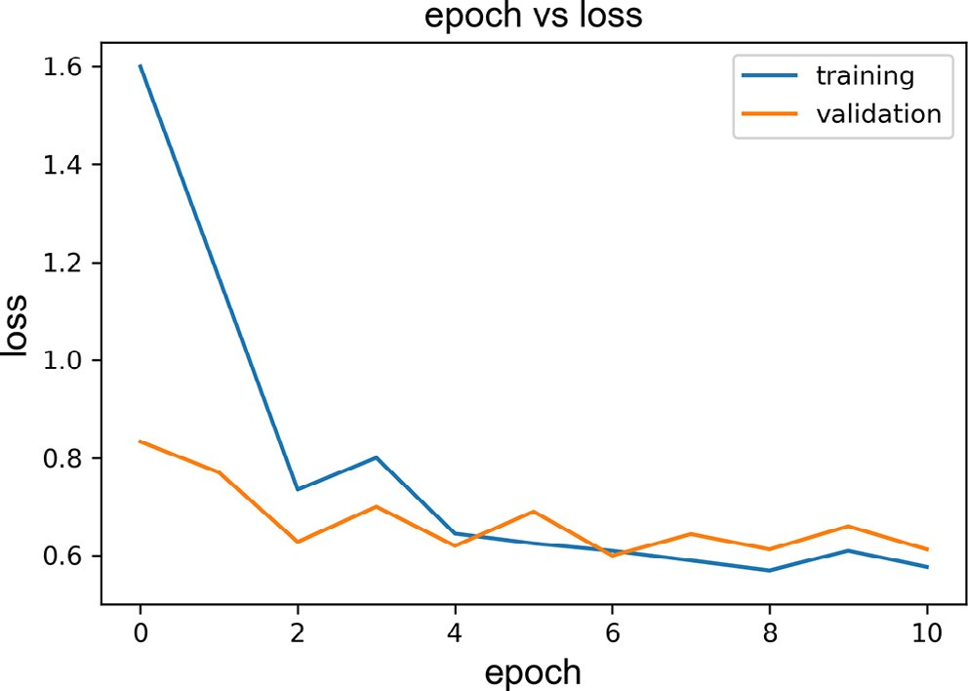.
Fig 6.loss curve showing the model's performance over 10 epochs.

4.5: Detection
The detection stage is responsible for locating traffic signs within an image and identifying their positions. This step plays a critical role in the overall system, as accurate detection ensures that only relevant regions are passed to the recognition stage. Detection involves identifying objects of interest and drawing bounding boxes around them.In this step, the trained deep learning model processes input images to detect potential traffic signs. The model scans the image and generates bounding boxes around regions where traffic signs are likely to be present. These bounding boxes define the coordinates of detected objects and help in isolating them from the background. Techniques such as Region Proposal Networks (RPN) are often used to efficiently generate candidate regions.Once bounding boxes are generated, the system assigns confidence scores to each detected region. These scores indicate the probability that a particular region contains a traffic sign. Non-Maximum Suppression (NMS) is applied to remove duplicate or overlapping bounding boxes, ensuring that only the most accurate detections are retained.After filtering, the system identifies the detected objects as traffic signs based on learned features. This involves classifying each bounding box into a specific category, such as speed limit signs, warning signs, or directional signs. The combination of localization (bounding boxes) and classification ensures precise detection.
Detection must also handle real-world challenges such as occlusion, varying lighting conditions, and complex backgrounds. Advanced models like Mask R-CNN improve detection accuracy by combining object detection with segmentation, allowing better boundary identification. Furthermore, detection is optimized for real-time performance, ensuring that the system can process images quickly without compromising accuracy. This is essential for applications like autonomous driving and driver assistance systems.
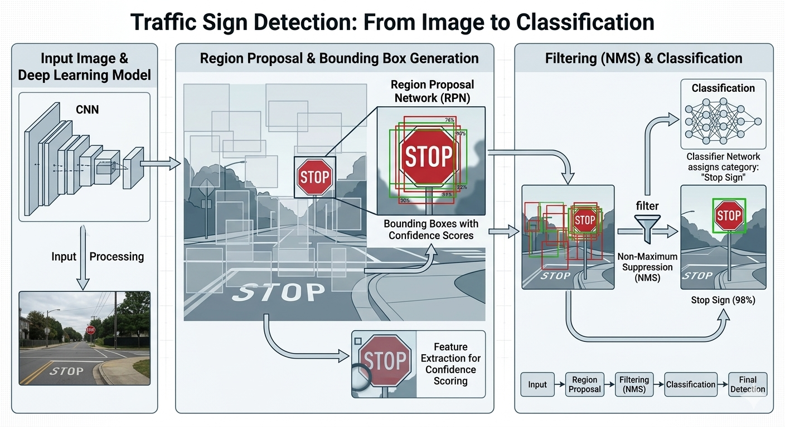
4.6: Recognition
The recognition stage is the final step in the traffic sign recognition pipeline, where the detected traffic signs are classified and interpreted to provide meaningful output. After the detection stage identifies and isolates traffic signs using bounding boxes, the recognition process focuses on understanding the content and category of each detected sign.
For text-based traffic signs, Optical Character Recognition (OCR) techniques are used. OCR enables the system to extract textual information from images, such as speed limits or written instructions. The detected region is first preprocessed to enhance text clarity, followed by character segmentation and recognition. OCR algorithms convert visual text into machine-readable format, allowing the system to interpret numerical values or words accurately.
For symbol-based traffic signs, histogram matching techniques are applied. Histogram matching compares the intensity distribution of the detected sign with predefined templates or reference images. By analyzing the similarity between histograms, the system can identify specific symbols such as arrows, warnings, or prohibition signs. This method is particularly useful for recognizing shapes and patterns where textual information is absent.
In addition to OCR and histogram matching, feature-based classification methods may also be used to improve recognition accuracy. Deep learning models trained during earlier stages can classify detected signs based on extracted features such as color, shape, and texture. This hybrid approach ensures better performance across different types of traffic signs.
The recognition stage must handle various challenges, including distortions, partial occlusion, and variations in sign appearance. To address these issues, preprocessing and feature enhancement techniques are applied before recognition.
Finally, the recognized traffic sign is converted into a meaningful output, such as displaying the sign category or providing instructions to the driver. This output can be integrated into driver assistance systems or autonomous vehicles for real-time decision-making.
.
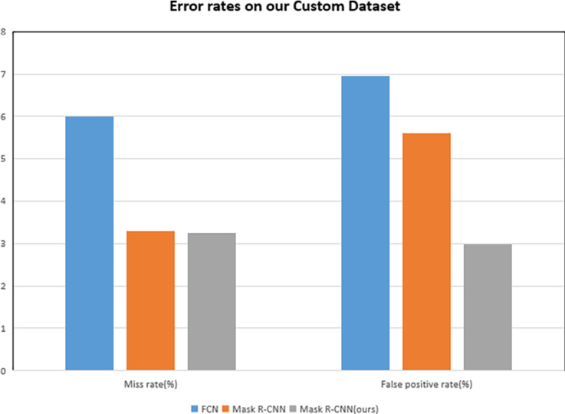

5. Major Findings / Results
The results obtained from this project demonstrate the effectiveness of deep learning-based approaches in traffic sign recognition, particularly when using the proposed Refined Mask R-CNN (RMR-CNN) model. A comparative analysis was performed between three models—Fast R-CNN, Mask R-CNN, and RMR-CNN—based on key performance metrics such as precision and recall. These metrics are essential in evaluating how accurately the model detects traffic signs and how well it minimizes false positives and false negatives.
The performance comparison is summarized below:
Model | Precision | Recall
Fast R-CNN | 93% | 94%
Mask R-CNN | 94.4% | 96.7%
RMR-CNN | 97.08% | 96.75%
From the table, it is evident that Fast R-CNN provides a strong baseline performance, achieving a precision of 93% and recall of 94%. However, its limitation lies in less accurate localization and inability to perform pixel-level segmentation. Mask R-CNN improves upon this by incorporating instance segmentation, resulting in better recall (96.7%) and improved precision (94.4%). This highlights its ability to detect more relevant traffic signs with fewer missed detections.
The proposed RMR-CNN model outperforms both baseline models, achieving the highest precision of 97.08% and a recall of 96.75%. This indicates that the model is highly accurate in identifying true traffic signs while minimizing incorrect detections. The improvement in precision suggests a significant reduction in false positives, while the high recall ensures that most traffic signs are successfully detected.
One of the key outcomes of this project is the improved overall accuracy achieved using the RMR-CNN model. By refining the architecture and incorporating better feature extraction and preprocessing techniques, the model demonstrates superior performance compared to traditional approaches. This makes it highly suitable for real-world applications where accuracy is critical.
Another important finding is the reduction in error rate, which is approximately 3% for the proposed model. This indicates that the system makes fewer incorrect predictions, enhancing reliability and consistency. Lower error rates are particularly important in safety-critical applications such as autonomous driving, where incorrect detection can lead to serious consequences.
The system also shows better performance under varying lighting conditions. Due to the use of data augmentation and advanced preprocessing techniques, the model is capable of handling images captured in different environments, including low light, shadows, and bright sunlight. This robustness ensures that the system performs consistently across diverse real-world scenarios.
Additionally, the model proves to be effective for real-time applications. Despite its high accuracy, the optimized architecture of RMR-CNN allows for efficient processing of images, making it suitable for deployment in systems such as Advanced Driver Assistance Systems (ADAS) and autonomous vehicles. The balance between speed and accuracy is a major achievement of this project.
Further analysis using confusion matrices and performance graphs reveals that the model performs particularly well in distinguishing between visually similar traffic signs. This is a result of improved feature extraction and training strategies.
In conclusion, the experimental results clearly demonstrate that the proposed RMR-CNN model provides significant improvements in precision, recall, and overall system performance. The findings validate the effectiveness of deep learning techniques in traffic sign recognition and highlight the potential of the system for real-world deployment in intelligent transportation systems.
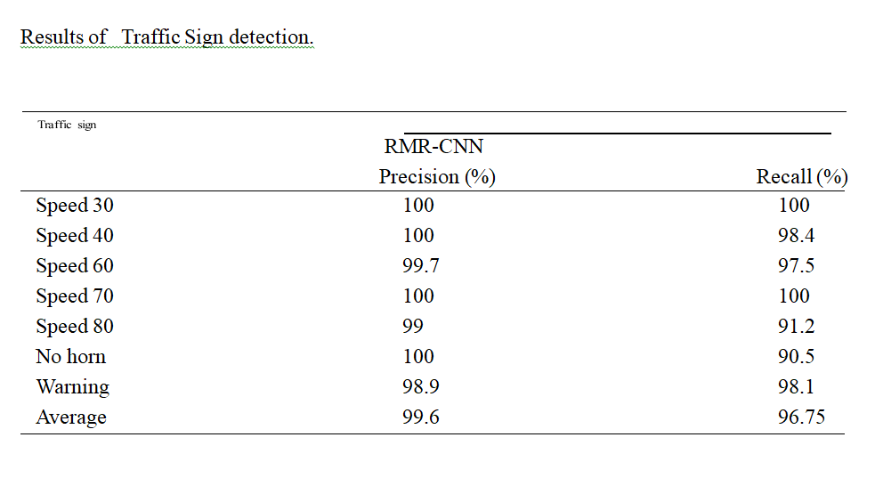
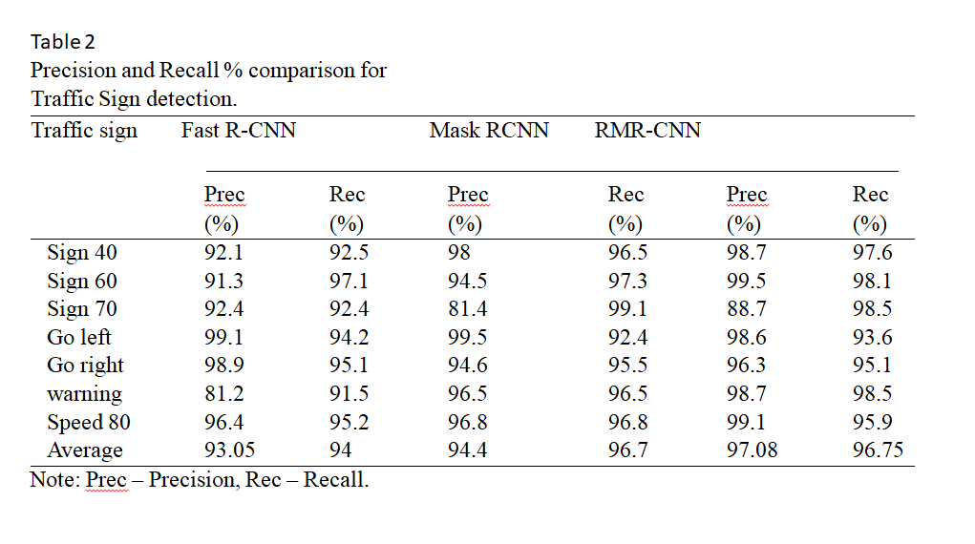
6.Conclusion
This project successfully demonstrates the application of deep learning techniques in the field of traffic sign recognition, highlighting the effectiveness of modern computer vision approaches in improving road safety and automation. The proposed Refined Mask R-CNN (RMR-CNN) model significantly enhances detection accuracy and overall system performance when compared to traditional models such as Fast R-CNN and Mask R-CNN. By incorporating refined feature extraction, improved region proposals, and optimized training strategies, the system achieves high precision and recall, making it reliable for real-world applications.
One of the key strengths of the developed system is its ability to handle lighting variations, which is a common challenge in real-world environments. Through preprocessing techniques and data augmentation methods, the model can effectively process images captured in low-light conditions, shadows, or bright sunlight. This ensures consistent performance regardless of environmental changes.
The system also demonstrates robustness in dealing with shape variations of traffic signs. Since traffic signs can appear in different orientations, sizes, and perspectives, the use of shape detection and CNN-based learning allows the model to accurately identify signs despite such variations. This capability is crucial for ensuring accurate recognition in dynamic driving conditions.
Another important achievement is the system’s ability to classify multiple traffic sign categories. With a dataset containing over 87 categories, the model effectively learns diverse patterns and features, enabling it to distinguish between different types of signs with high accuracy. This scalability makes the system suitable for deployment in complex traffic environments.
Overall, the project provides a strong foundation for intelligent transportation systems and contributes to the advancement of autonomous driving technologies. The integration of deep learning models with efficient preprocessing and detection techniques ensures a balance between accuracy, speed, and reliability.
6.1Future Scope
While the current system achieves promising results, there are several opportunities for further improvement and expansion. One potential direction is the integration with autonomous vehicles, where the system can be directly embedded into self-driving platforms to assist in real-time decision-making. This would enhance vehicle safety and automation capabilities.
Another area of development is the creation of a real-time mobile application. By optimizing the model for lightweight deployment, the system can be implemented on smartphones or portable devices, making it accessible for practical use in navigation and driver assistance.
The use of larger and more diverse datasets can further improve model performance. Expanding the dataset to include more traffic sign categories, geographical variations, and challenging conditions will enhance the model’s generalization ability.
Additionally, implementation on edge devices such as embedded systems or IoT-based platforms can make the system more efficient and suitable for real-time applications with low latency.
Finally, future enhancements can include the adoption of advanced models such as YOLO (You Only Look Once) for faster object detection or Transformer-based architectures for improved feature learning and scalability. These advancements have the potential to further boost accuracy and processing speed.

7 . REFERENCES :
- J. Redmon et al., “You Only Look Once: Unified, Real-Time Object Detection,” 2016.
- K. He et al., “Mask R-CNN,” IEEE ICCV, 2017.
- R. Girshick, “Fast R-CNN,” IEEE ICCV, 2015.
- A. Krizhevsky et al., “ImageNet Classification with Deep CNNs,” NIPS, 2012.
- S. Ren et al., “Faster R-CNN,” IEEE TPAMI, 2016.
- Y. LeCun et al., “Deep Learning,” Nature, 2015.
- M. Everingham et al., “The Pascal Visual Object Classes Challenge,” IJCV, 2010.
- D. Lowe, “Distinctive Image Features from Scale-Invariant Keypoints,” IJCV, 2004.
- N. Dalal and B. Triggs, “Histograms of Oriented Gradients,” CVPR, 2005.
- OpenCV Documentation, “Computer Vision Library,” 2023.
- TensorFlow Documentation, Google, 2023.
- PyTorch Documentation, Meta AI, 2023.
- NumPy Documentation, 2023.
- Matplotlib Documentation, 2023.
- German Traffic Sign Recognition Benchmark (GTSRB), 2013.
- Belgian Traffic Sign Dataset (BTSD), 2015.
- M. Teichmann et al., “MultiNet: Real-time Joint Semantic Reasoning,” 2018.
- Z. Zhu et al., “Traffic-Sign Detection and Classification,” IEEE TITS, 2016.
- C. Szegedy et al., “Going Deeper with Convolutions,” CVPR, 2015.
- A. Howard et al., “MobileNets,” 2017.
- J. Deng et al., “ImageNet Dataset,” CVPR, 2009.
- H. Caesar et al., “nuScenes Dataset,” 2020.
- T. Lin et al., “Microsoft COCO Dataset,” 2014.
- B. Wu et al., “SqueezeDet,” 2017.
- X. Liu et al., “SSD: Single Shot MultiBox Detector,” ECCV, 2016.
- J. Long et al., “Fully Convolutional Networks,” CVPR, 2015.
- A. Dosovitskiy et al., “Vision Transformer,” 2021.
- Y. Wang et al., “Transformer-based Object Detection,” 2020.
- J. Zhang et al., “Real-time Traffic Sign Recognition,” IEEE Access, 2019.
- S. Houben et al., “Detection of Traffic Signs in Real-world Images,” 2013.
- IEEE Standards on Intelligent Transportation Systems, 2022.
- World Health Organization, “Road Safety Report,” 2021.
- NVIDIA, “GPU Acceleration for Deep Learning,” 2022.
- Intel, “Computer Vision Applications,” 2021.
- Google AI Blog, “Advances in Object Detection,” 2022.
- Coursera Deep Learning Specialization, 2023.
- Stanford CS231n Notes, “CNN for Visual Recognition,” 2023.
- MIT OpenCourseWare, “Deep Learning for Vision,” 2022.
- Kaggle Datasets on Traffic Sign Recognition, 2023.
- Udacity Self-Driving Car Nanodegree Materials, 2022.
- J. Brownlee, “Deep Learning for Computer Vision,” 2019.
- I. Goodfellow et al., “Deep Learning Book,” MIT Press, 2016.
- R. Szeliski, “Computer Vision: Algorithms and Applications,” 2010.
- S. Russell and P. Norvig, “Artificial Intelligence,” 2020.
- Bishop, “Pattern Recognition and Machine Learning,” 2006.
- Scikit-learn Documentation, 2023.
- YOLOv5 GitHub Repository, 2023.
- Detectron2 by Facebook AI, 2023.
- Keras Documentation, 2023.
- Hugging Face Transformers Library, 2023.
Appendix A: Dataset Details
The dataset used in this project plays a crucial role in training and evaluating the traffic sign recognition system. A total of 6480 images were collected and curated to ensure diversity and real-world relevance. These images include more than 87 traffic sign categories, covering a wide range of regulatory, warning, and informational signs.
The dataset was designed to reflect real-world conditions by including variations in lighting, weather, background complexity, and viewing angles. Images were sourced from road environments, publicly available datasets, and simulated scenarios to ensure a comprehensive representation of traffic conditions. Each image was carefully annotated with corresponding labels and, where applicable, bounding box information to support supervised learning.
Proper dataset organization was maintained by grouping images into category-specific folders, enabling efficient data handling during training and testing. This structured dataset significantly contributed to the robustness and accuracy of the model, allowing it to generalize well across different scenarios.
Appendix B: Sample Code
The following code snippet demonstrates a basic image preprocessing step using Python and OpenCV. It shows how an image is loaded and converted into grayscale format, which is commonly used in preprocessing to simplify image data and reduce computational complexity.
import cv2

# Load the input image
image = cv2.imread('image.jpg')

# Convert the image to grayscale
gray = cv2.cvtColor(image, cv2.COLOR_BGR2GRAY)

# Display the grayscale image
cv2.imshow("Grayscale Image", gray)
cv2.waitKey(0)
cv2.destroyAllWindows()
This code represents a fundamental step in the preprocessing pipeline, where color images are transformed into grayscale to focus on structural features such as edges and shapes. Such preprocessing steps are essential before applying advanced techniques like feature extraction and model training.

